List of Practical
Sr. No | Program Title | CO  Mapping
 | Implementation of Linux Commands  Introduction of Unix/Linux Operating system and their architecture  Display system information using uname, hostname, and date etc.  File operations using cat, touch, cp, mv, rm, and chmod ,umask etc.  Create, view, and navigate directories using mkdir, rmdir, cd, pwd, ls etc.  Disk Commands df, du, mount, unmount, mkfs, fsck etc.  Use redirection and piping in commands  File compression and archiving using tar, gzip, zip, unzip etc.  Process commands ps,kill, killall,nice, pgrep, top,htop etc.  Network commands ifconfig, ping, netstat, host,ip route etc.  Administrator Commands Adduser, Passwd, deluser, usermod, groupadd etc | CO1
 | Shell Scripting Programming  Write a shell script to ask your name, program name and enrollment number and print it on the screen.  Write a shell script to find the sum, the average and the product of the four integers entered.  write shell script to find average of numbers given at command line  Write a shell program to exchange the values of two variables  Write a shell program to Print Numbers 1 to 10 using while & do while loop.  Write a shell program to Print Numbers 1 to 10 using for loop.  Write a shell script to display the digits which are in odd position in a given 5-digit number.  Write a shell program to search for a given number from the list of numbers provided using binary search method.  Write a shell program to concatenate two strings and find the length of the resultant string  Write a shell script to find the smallest of three numbers  Write a shell program to count number of words, characters, white spaces and special symbols in a given text | CO1
 | Process & Thread Management
 | Introduction to C Programming (Statement, Conditional Statement, Loop, Array & Function) | CO2
 | Implement FCFS CPU Scheduling algorithm. | CO2
 | Implement the SJF CPU Scheduling algorithm (For both Pre-emptive and non-pre-emptive). | CO2
 | Implement PRIORITY CPU Scheduling Algorithm (For both Pre-emptive and non-pre-emptive). | CO2
 | Implement Round-Robin CPU Scheduling Algorithm | CO2
 | Implement Multi-Level Queue CPU Scheduling algorithm. | CO2
 | Implement Multilevel Queue CPU Scheduling Algorithm. | CO2
 | Concurrency and Deadlock Management
 | Execute the RACE Condition of Process Synchronization. | CO2
 | Implement the Producer–consumer problem using semaphores. | CO2
 | Design a code and implement the Dinning Philosopher problem. | CO2
 | Implement Banker’s algorithm of Deadlock Avoidance. | CO2
 | Execute an algorithm for Deadlock Detection. | CO2
 | Memory Management
 | Implement Contiguous memory variable size partition scheme. | CO3
 | Simulate the First-Fit contiguous memory allocation technique. | CO3
 | Simulate the Best-Fit contiguous memory allocation technique. | CO3
 | Simulate the Worst-Fit contiguous memory allocation technique. | CO3
 | Implement the Non-contiguous Memory Allocation by using Paging. | CO3
 | Implement Contiguous memory variable size partition scheme. | CO3
 | Page Replacement
 | Write a Program to simulate the FIFO page replacement algorithm. | CO3
 | Write a Program to simulate the LRU page replacement Algorithm. | CO3
 | Write a Program to simulate the Optimal page replacement Algorithm. | CO3
 | Disk Scheduling | CO3
 | Write a program to simulate FCFS Disk Scheduling Algorithm. | CO3
 | Write a Program to simulate the SSTF Disk Scheduling Algorithm. | CO3
 | Write a program to simulate SCAN Disk Scheduling Algorithm. | CO3
 | Write a Program to simulate the C SCAN Disk Scheduling Algorithm. | CO3
 | Write a Program to simulate the LOOK Disk Scheduling Algorithm. | CO3
 | Modern Operating System | CO3
 | Introduction of CUDA Programming. | CO3
 | Write a program in CUDA print message “Welcome CUDA programming” | CO3
 | Implement matrix multiplication using shared memory in CUDA. | CO3
 | Connects to VMware vCenter and lists all virtual machines along with their power state. | CO3
 | Create a new virtual machine in Azure with specified configurations. | CO3
 | Deploy a simple HTTP-triggered distributed Azure Function. | CO3
Total Hours: |  | 48
*Competitive coding list will be shared with the students.

 | NOIDA INSTITUTE OF ENGINEERING & TECHNOLOGY, GR. NOIDA |  | Session:  2025-26
 |  |  | III Semester
DEPARTMENT OF COMPUTER SCIENCE AND ENGINEERING

1.Write a shell script to ask your name, program name and enrolment number and print it on the screen.

STEP 1 : Create a file named- nano userinfo.sh
STEP 2: Write the code and then,Press CTRL + X, then Y, and hit Enter to save and exit.
STEP 3: To execute the file type - chmod +x userinfo.sh
STEP 4: For output type- ./ userinfo.sh
CODE
echo "Enter your name:"
read name
echo "Enter your program name:"
read program
echo "Enter your enrollment number:"
read enroll
echo "Name: $name"
echo "Program: $program"
echo "Enrollment Number: $enroll"
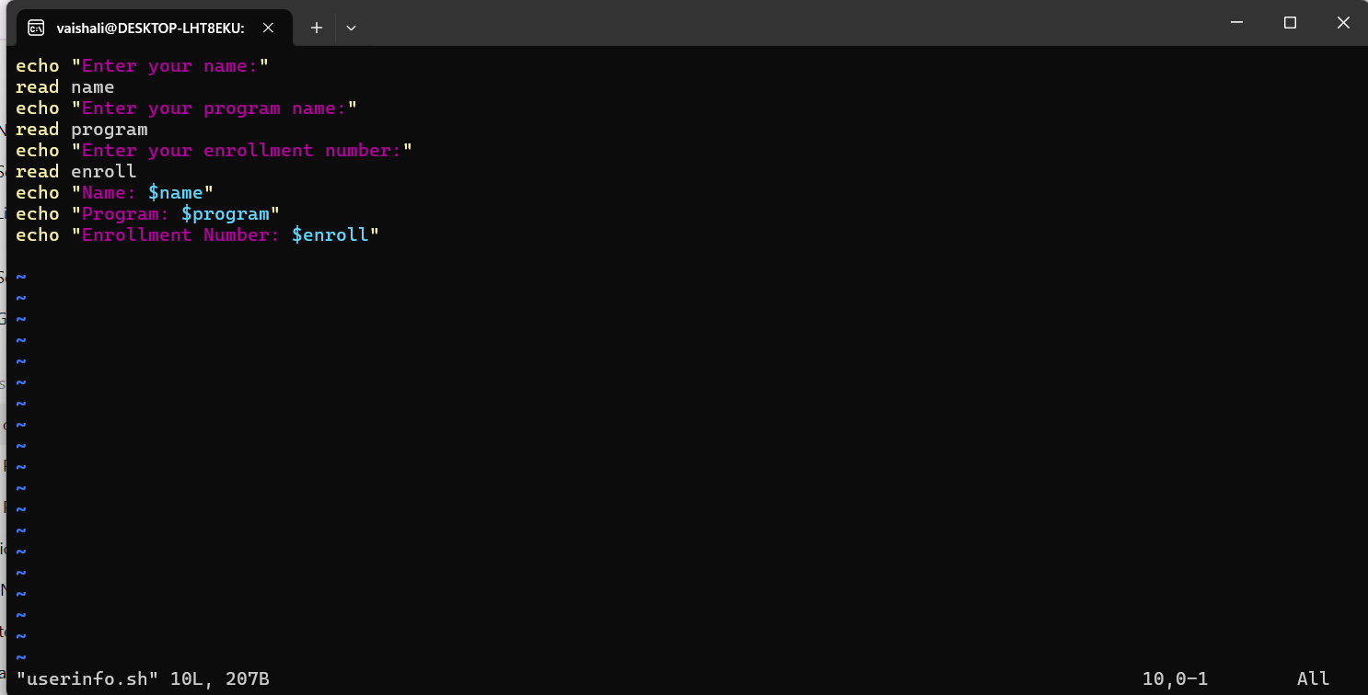

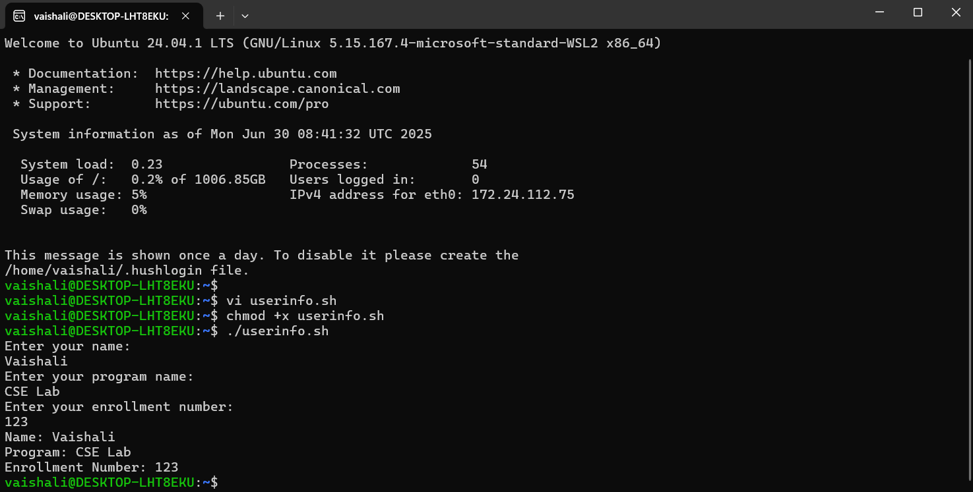

2.Write a shell script Sum, average, and product of 4 integers

STEP 1 : Create a file named- vi mathcalcul2.sh
STEP 2: Press I, Write the code and then,Press Esc , then :wq, and hit Enter to save and exit.(if force quit then :q!).
STEP 3: To execute the file type chmod +x mathcalcul2.sh
STEP 4: For output type ./mathcalcul2.sh
#!/bin/bash
echo "Enter four integers:"
read a b c d
sum=$((a + b + c + d))
avg=$((sum / 4))
prod=$((a * b * c * d))
echo "Sum: $sum"
echo "Average: $avg"
echo "Product: $prod"
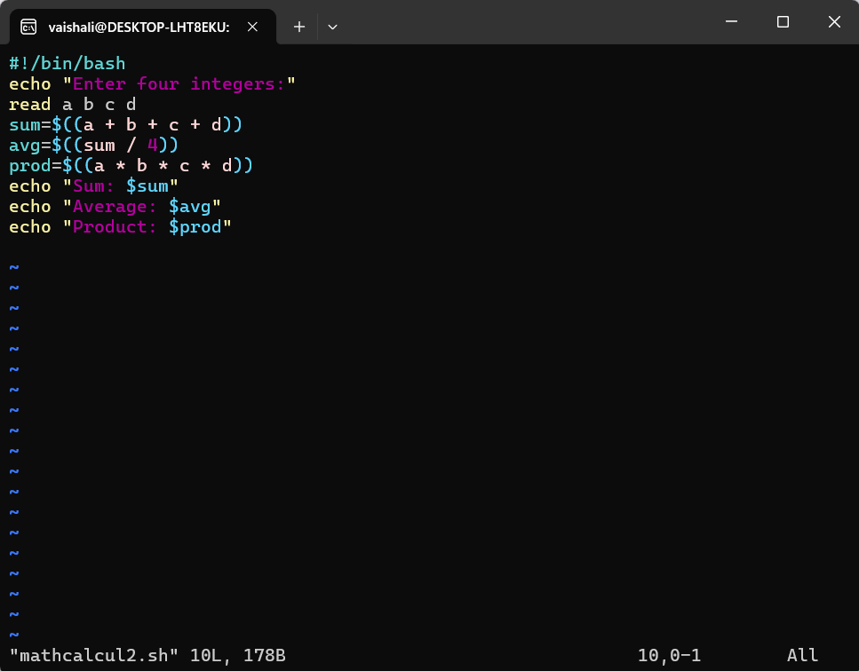

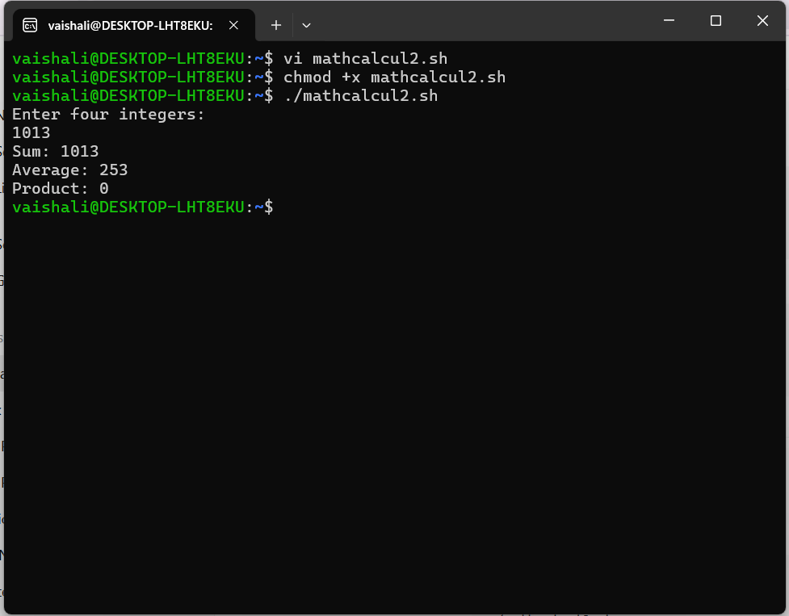

3. write shell script to find average of numbers given at command line

STEP 1 : Create a file named- vi avgcmd.sh
STEP 2: Press I, Write the code and then,Press Esc , then :wq, and hit Enter to save and exit.(if force quit then :q!).
STEP 3: To execute the file type chmod +x avgcmd.sh
STEP 4: For output type ./avgcmd.sh 10 20 30 40 (Since you didn't pass any numbers, $# (which stores the number of arguments) was 0, leading to this line failing: avg=$((sum / count)) # becomes avg=$((0 / 0)))

#!/bin/bash
sum=0
count=$#
for num in "$@"
do
sum=$((sum + num))
done
avg=$((sum / count))
echo "Average: $avg"

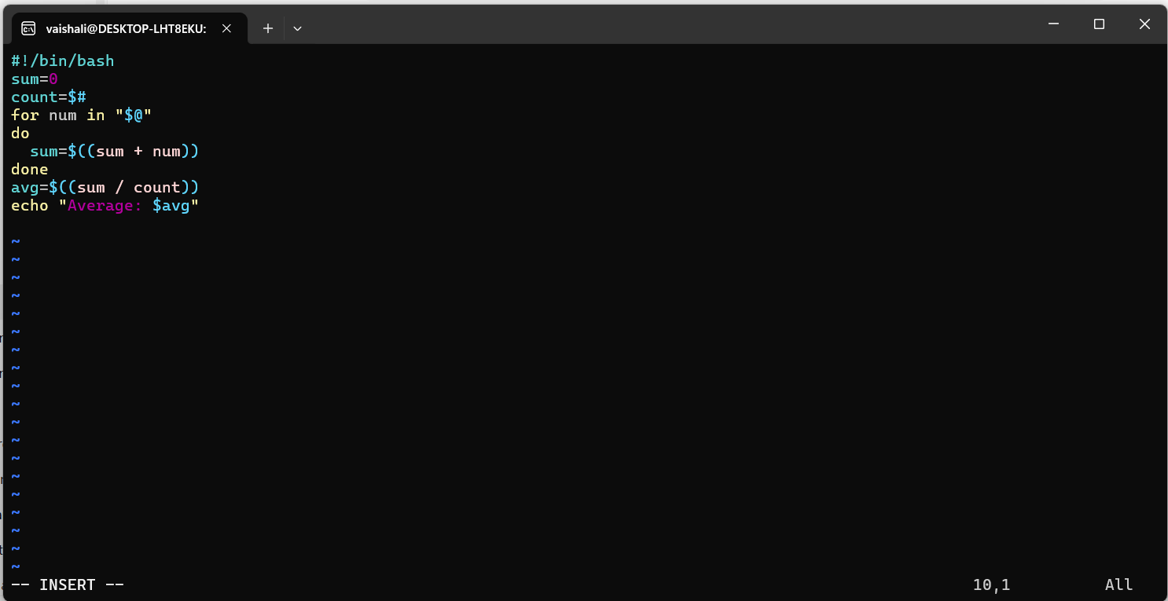
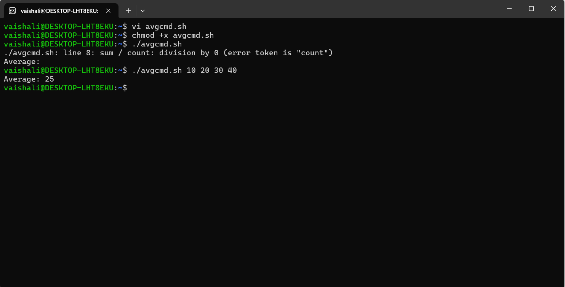

4. Write a shell program to exchange the values of two variables

STEP 1 : Create a file named- swap.sh
STEP 2: Press I, Write the code and then,Press Esc , then :wq, and hit Enter to save and exit.(if force quit then :q!).
STEP 3: To execute the file type chmod +x swap.sh
STEP 4: For output type ./ swap.sh

#!/bin/bash
echo "Enter first number:"
read a
echo "Enter second number:"
read b
echo "Before Swap: a=$a, b=$b"
temp=$a
a=$b
b=$temp
echo "After Swap: a=$a, b=$b"
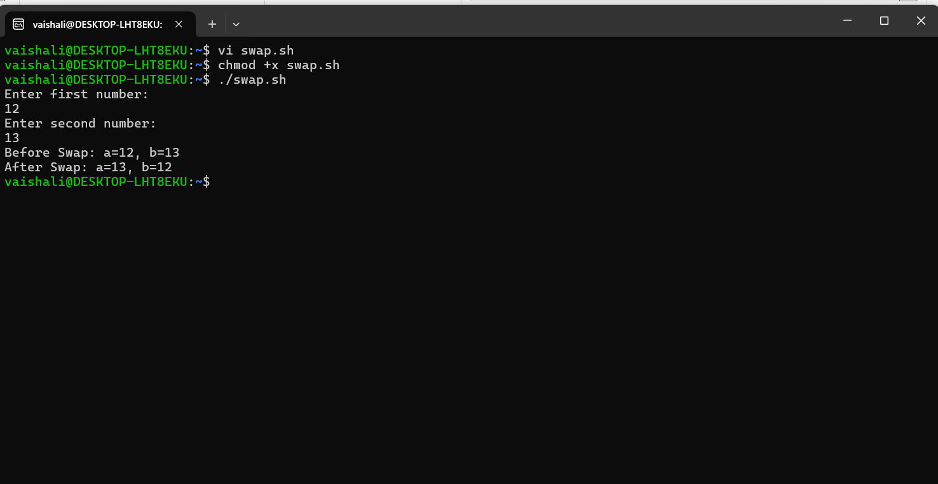
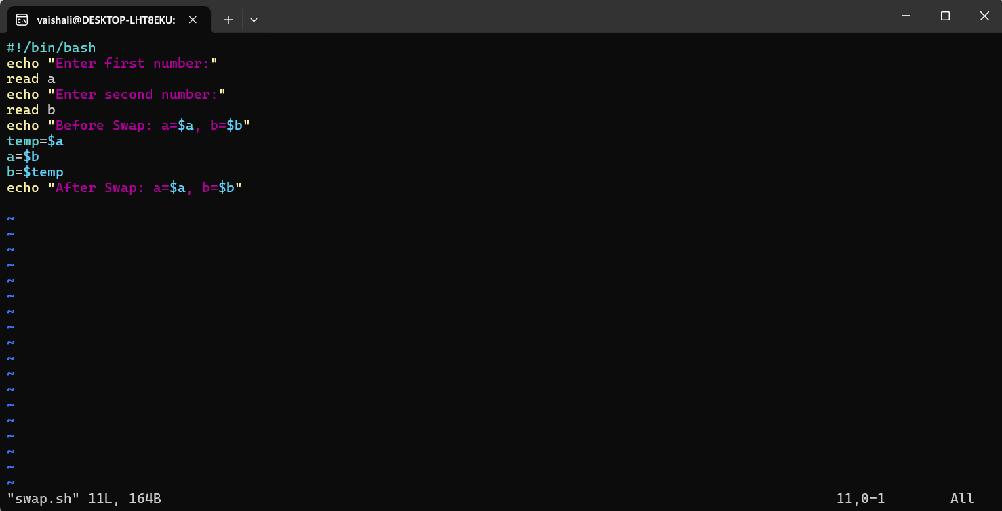

5. Write a shell program to Print Numbers 1 to 10 using while & do while loop.

STEP 1 : Create a file named- vi dowhileloop.sh
STEP 2: Press I, Write the code and then,Press Esc , then :wq, and hit Enter to save and exit.(if force quit then :q!).
STEP 3: To execute the file type chmod +x dowhileloop.sh
STEP 4: For output type ./ dowhileloop.sh
Here -le less than
-gt greater than

#!/bin/bash

# Using while loop
echo "Numbers from 1 to 10 using while loop:"
i=1
while [ $i -le 10 ]
do
echo $i
i=$((i + 1))
done

echo "" # Blank line for separation

o# Simulating do-while loop
echo "Numbers from 1 to 10 using simulated do-while loop:"
j=1
while true
do
echo $j
j=$((j + 1))
if [ $j -gt 10 ]; then
break
fi
done
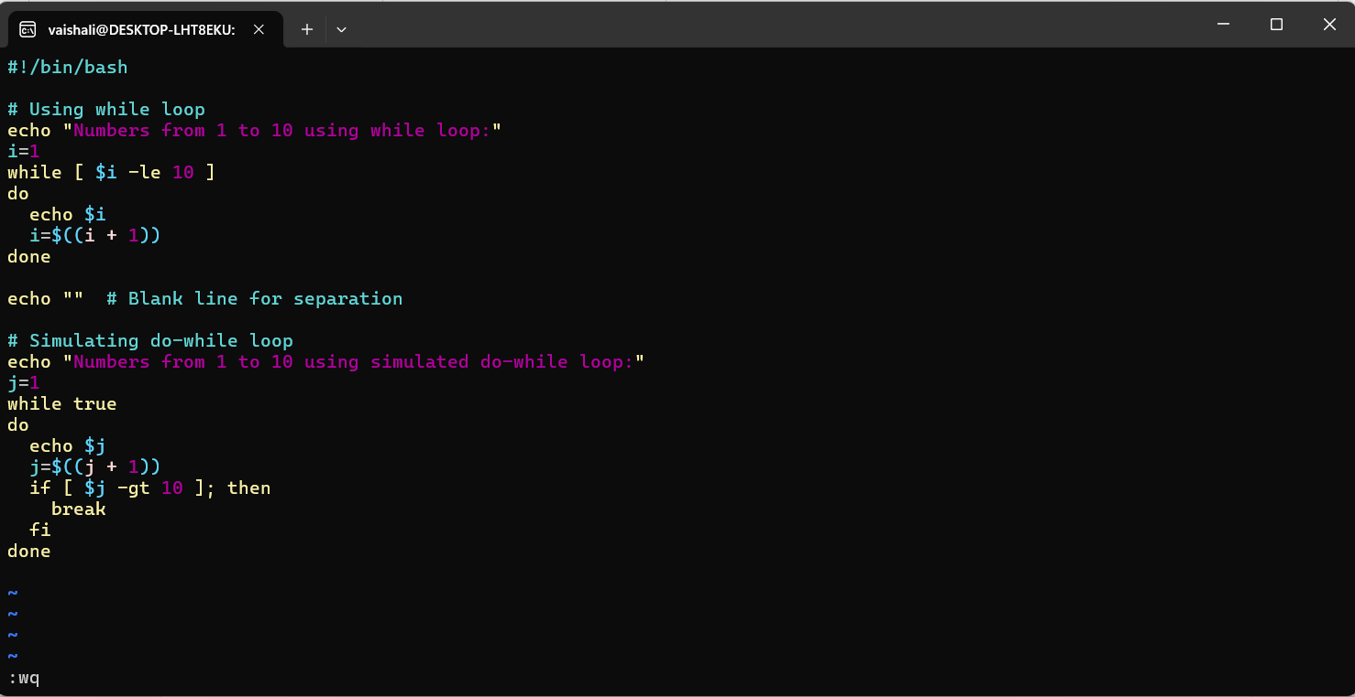
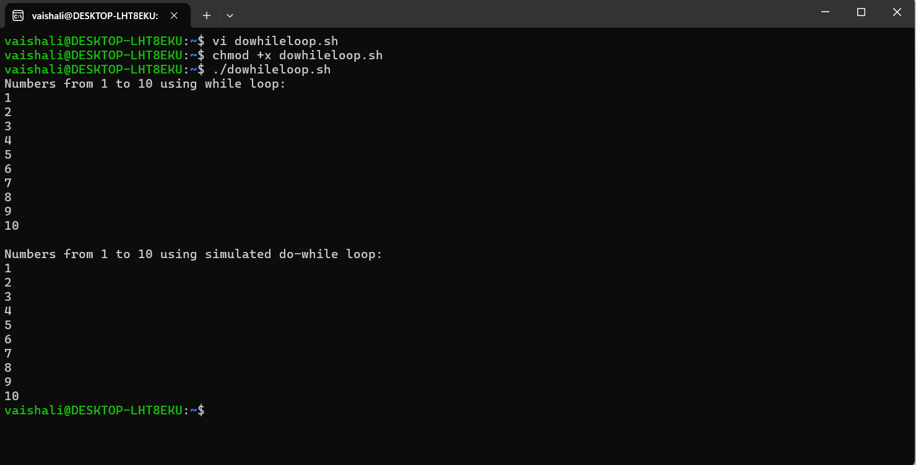

6. Write a shell program to Print Numbers 1 to 10 using for loop.

STEP 1 : Create a file named- vi forloopp.sh
STEP 2: Press I, Write the code and then,Press Esc , then :wq, and hit Enter to save and exit.(if force quit then :q!).
STEP 3: To execute the file type chmod +x forloopp.sh
STEP 4: For output type ./ forloopp.sh

#!/bin/bash

echo "Numbers from 1 to 10 using for loop:"

for i in {1..10}
do
echo $i
done
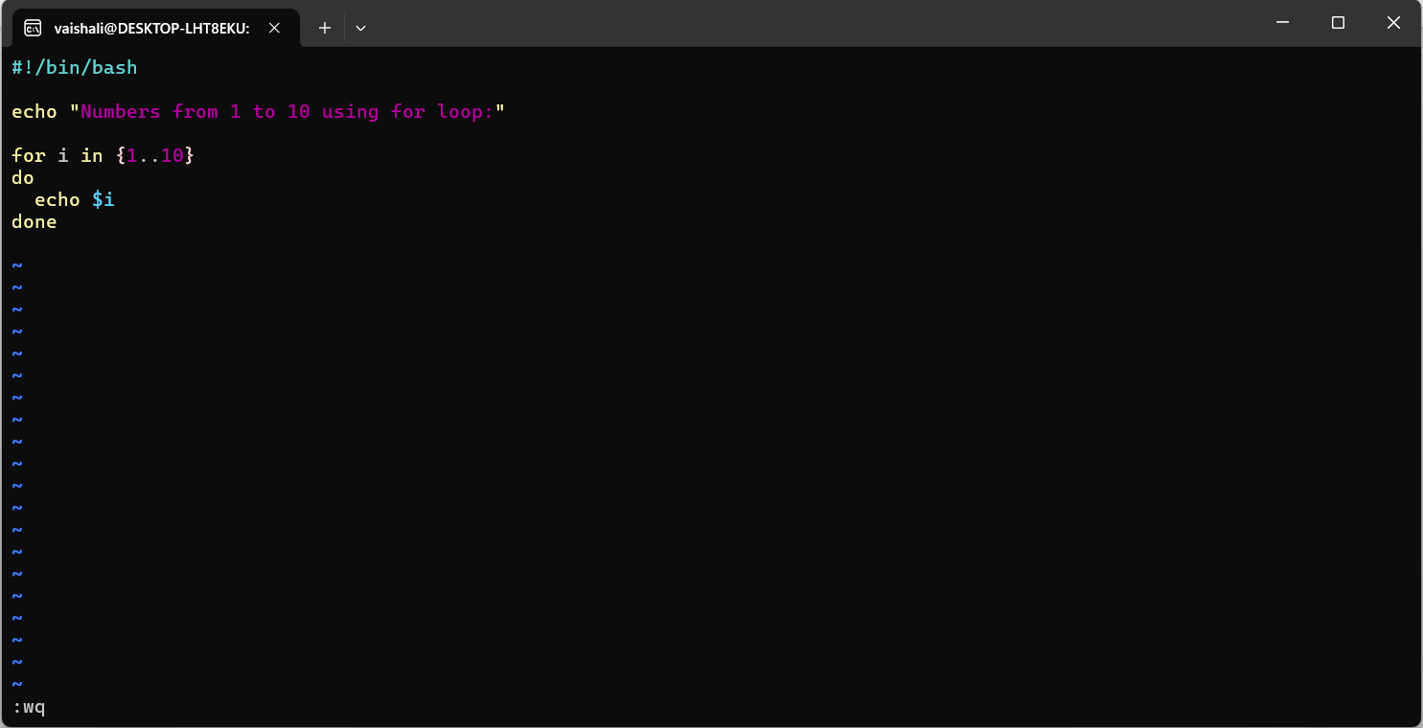
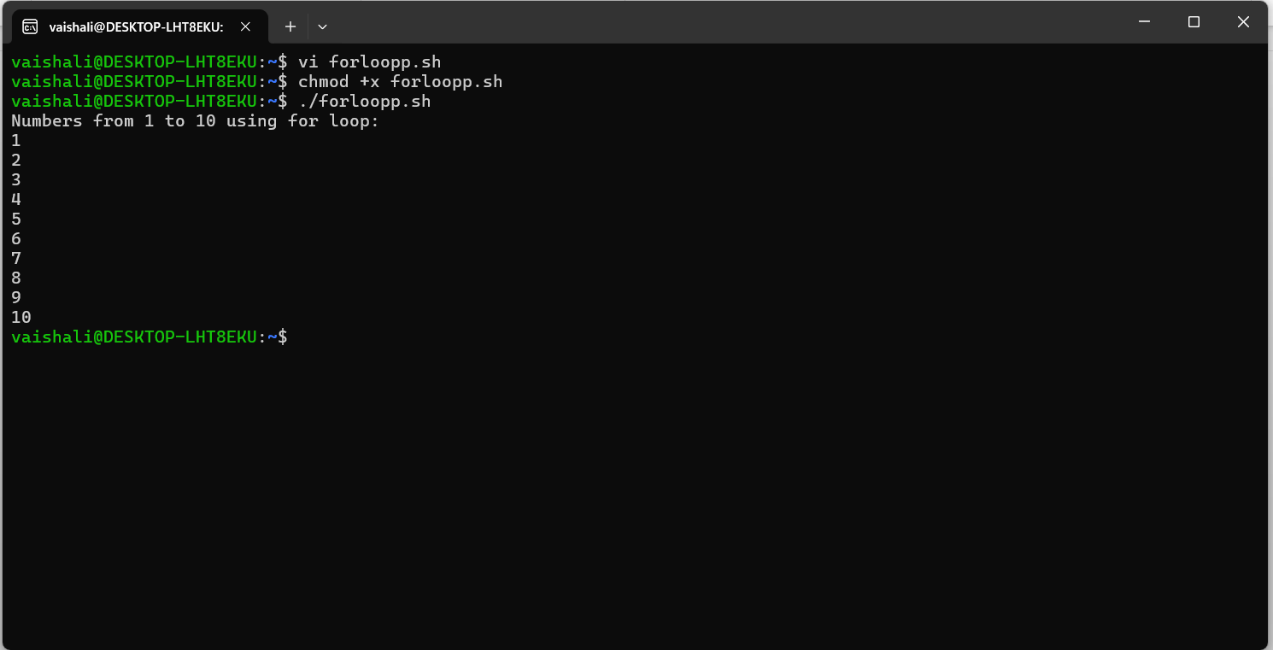

7. Write a shell script to display the digits which are in odd position in a given 5-digit number.

STEP 1 : Create a file named- vi cuttcomand.sh
STEP 2: Press I, Write the code and then,Press Esc , then :wq, and hit Enter to save and exit.(if force quit then :q!).
STEP 3: To execute the file type chmod +x cuttcomand.sh
STEP 4: For output type ./ cuttcomand.sh
Cut command Extracts the 1st, 3rd 5th character of the input.
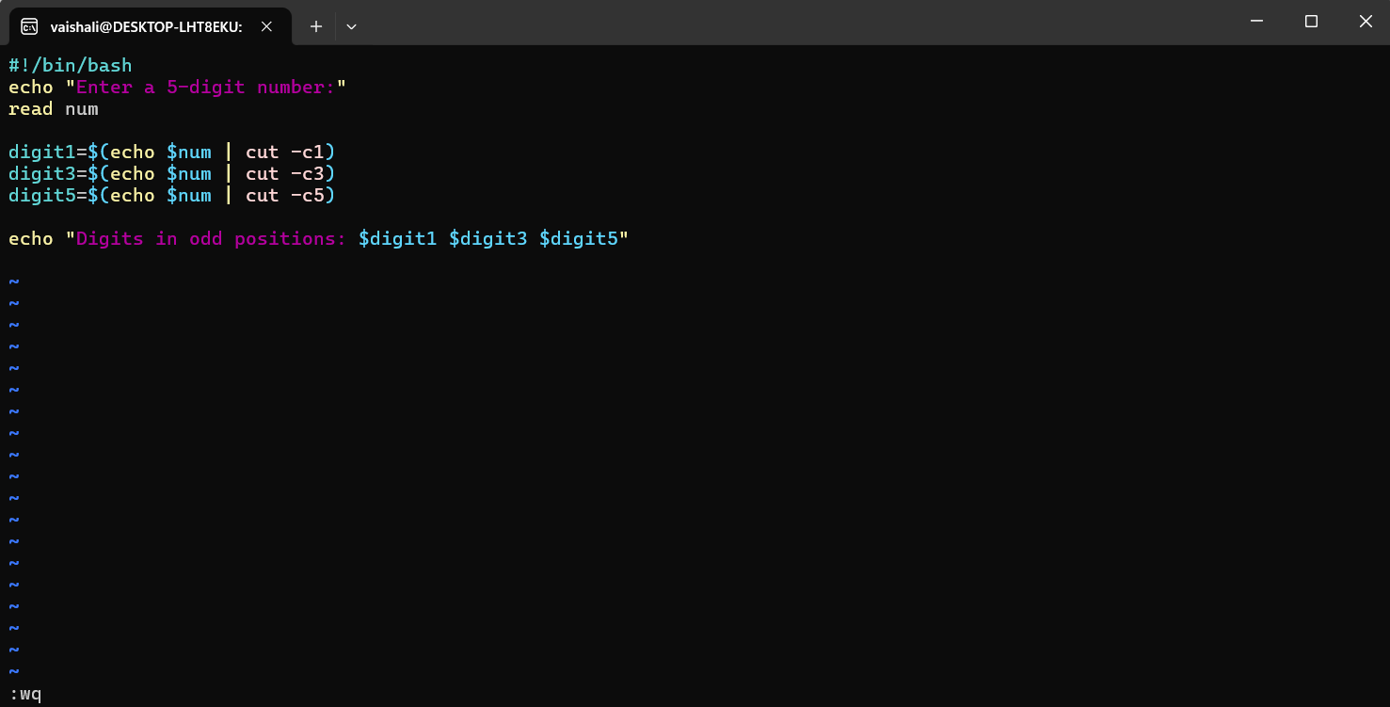
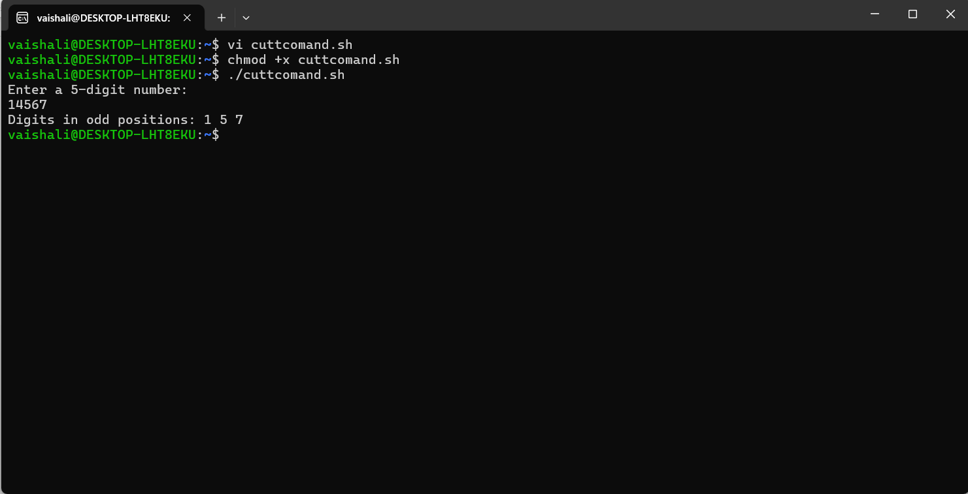

8. Write a shell program to search for a given number from the list of numbers provided using binary search method.

STEP 1 : Create a file named- vi binarysearch.sh
STEP 2: Press I, Write the code and then,Press Esc , then :wq, and hit Enter to save and exit.(if force quit then :q!).
STEP 3: To execute the file type chmod +x binarysearch.sh
STEP 4: For output type ./ binarysearch.sh

#!/bin/bash
echo "Enter sorted numbers (space separated):"
read -a arr
echo "Enter number to search:"
read key
low=0
high=$((${#arr[@]} - 1))
while [ $low -le $high ]
do
mid=$(((low + high) / 2))
if [ ${arr[$mid]} -eq $key ]; then
echo "Found at position $((mid+1))"
exit 0
elif [ ${arr[$mid]} -lt $key ]; then
low=$((mid + 1))
else
high=$((mid - 1))
fi
done
echo "Not Found"

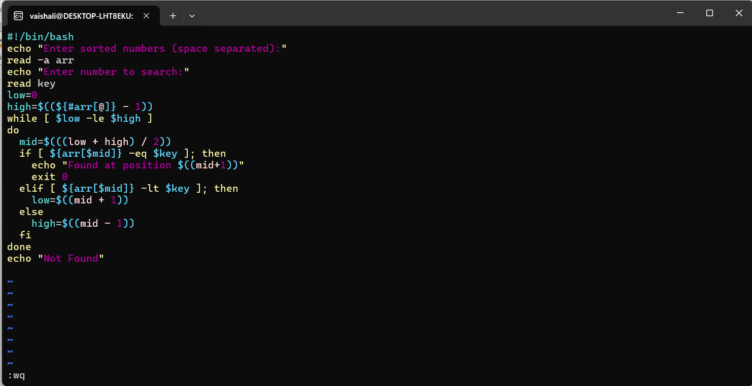
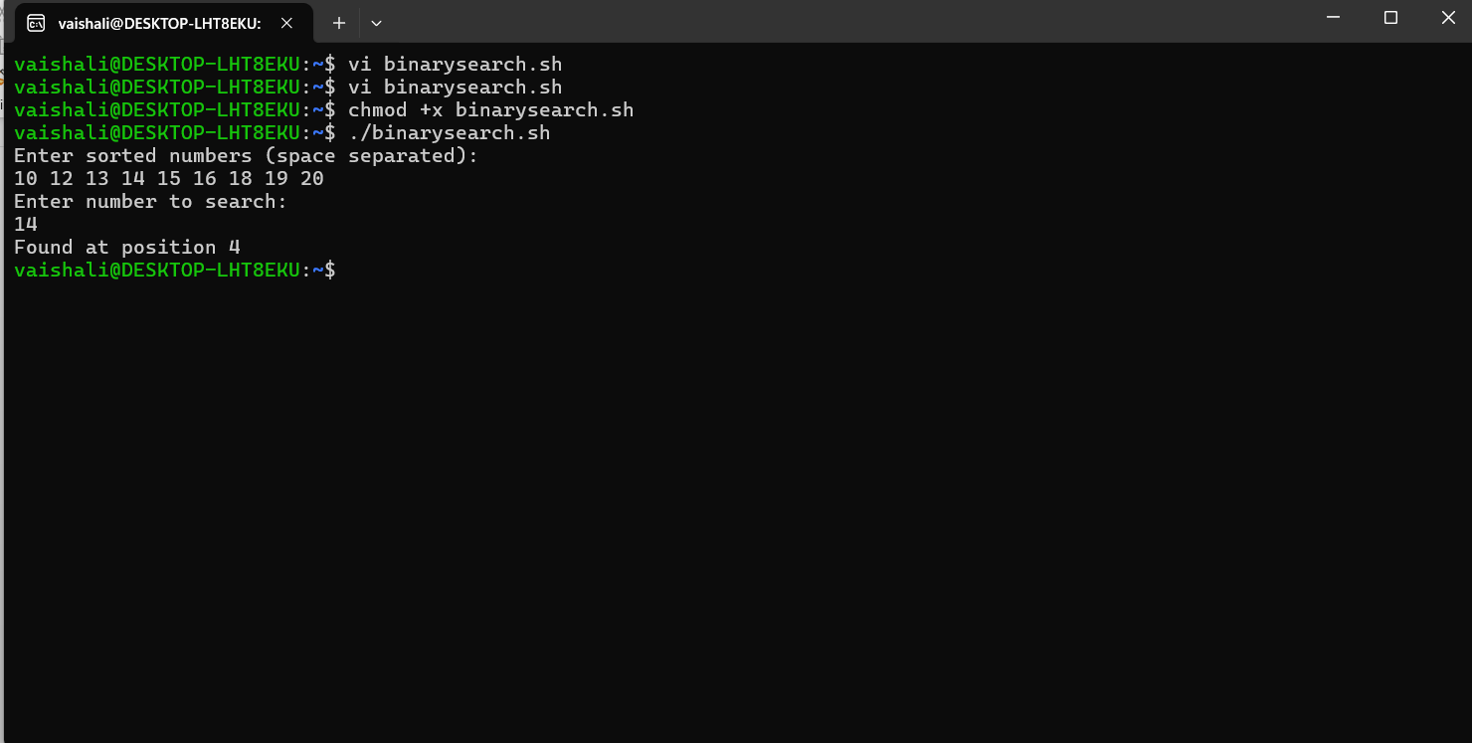

9. Write a shell program to concatenate two strings and find the length of the resultant string

STEP 1 : Create a file named- vi concatlen.sh
STEP 2: Press I, Write the code and then,Press Esc , then :wq, and hit Enter to save and exit.(if force quit then :q!).
STEP 3: To execute the file type chmod +x concatlen.sh
STEP 4: For output type ./ concatlen.sh

#!/bin/bash
echo "Enter first string:"
read str1
echo "Enter second string:"
read str2
concat="$str1$str2"
echo "Concatenated string: $concat"
echo "Length: ${#concat}"
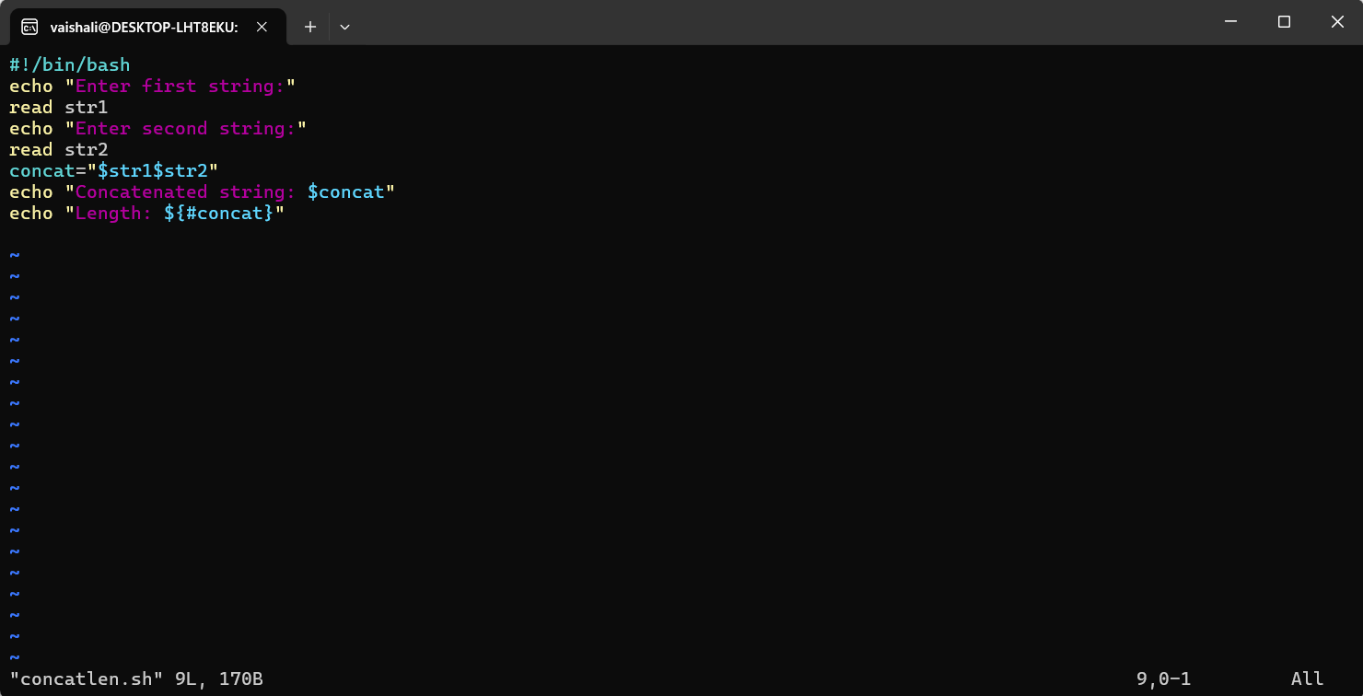

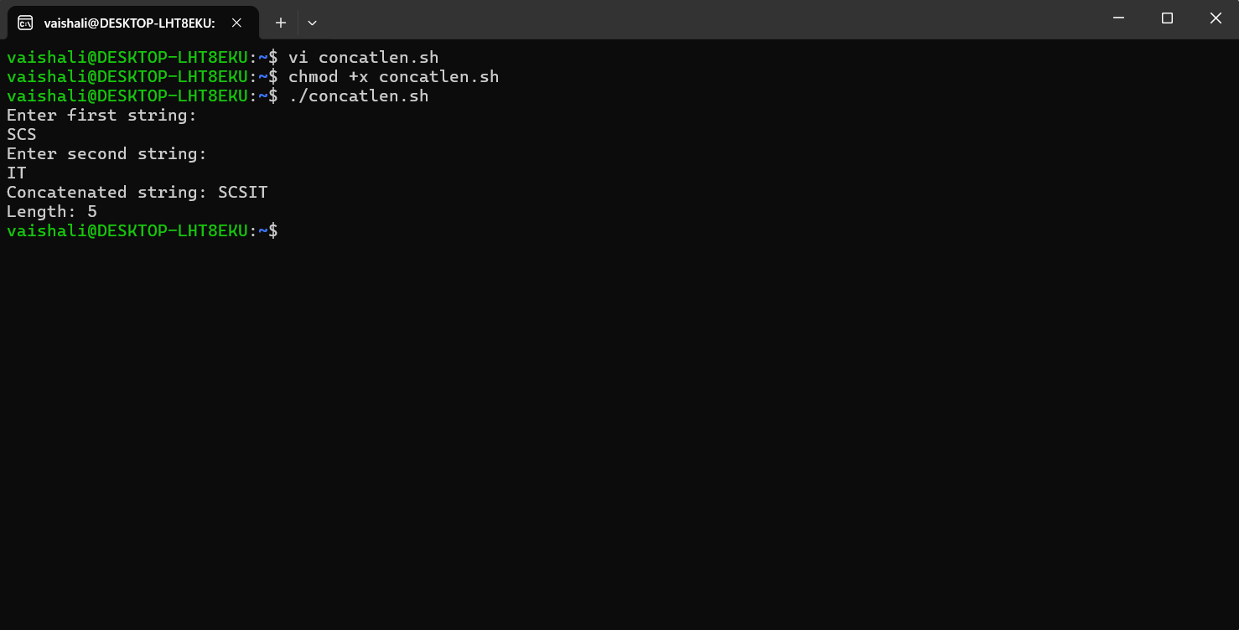

10. Write a shell script to find the smallest of three numbers

STEP 1 : Create a file named- vi smallest.sh
STEP 2: Press I, Write the code and then,Press Esc , then :wq, and hit Enter to save and exit.(if force quit then :q!).
STEP 3: To execute the file type chmod +x smallest.sh
STEP 4: For output type ./ smallest.sh

#!/bin/bash
echo "Enter three numbers:"
read a b c
if [ $a -le $b ] && [ $a -le $c ]; then
echo "$a is smallest"
elif [ $b -le $a ] && [ $b -le $c ]; then
echo "$b is smallest"
else
echo "$c is smallest"
fi

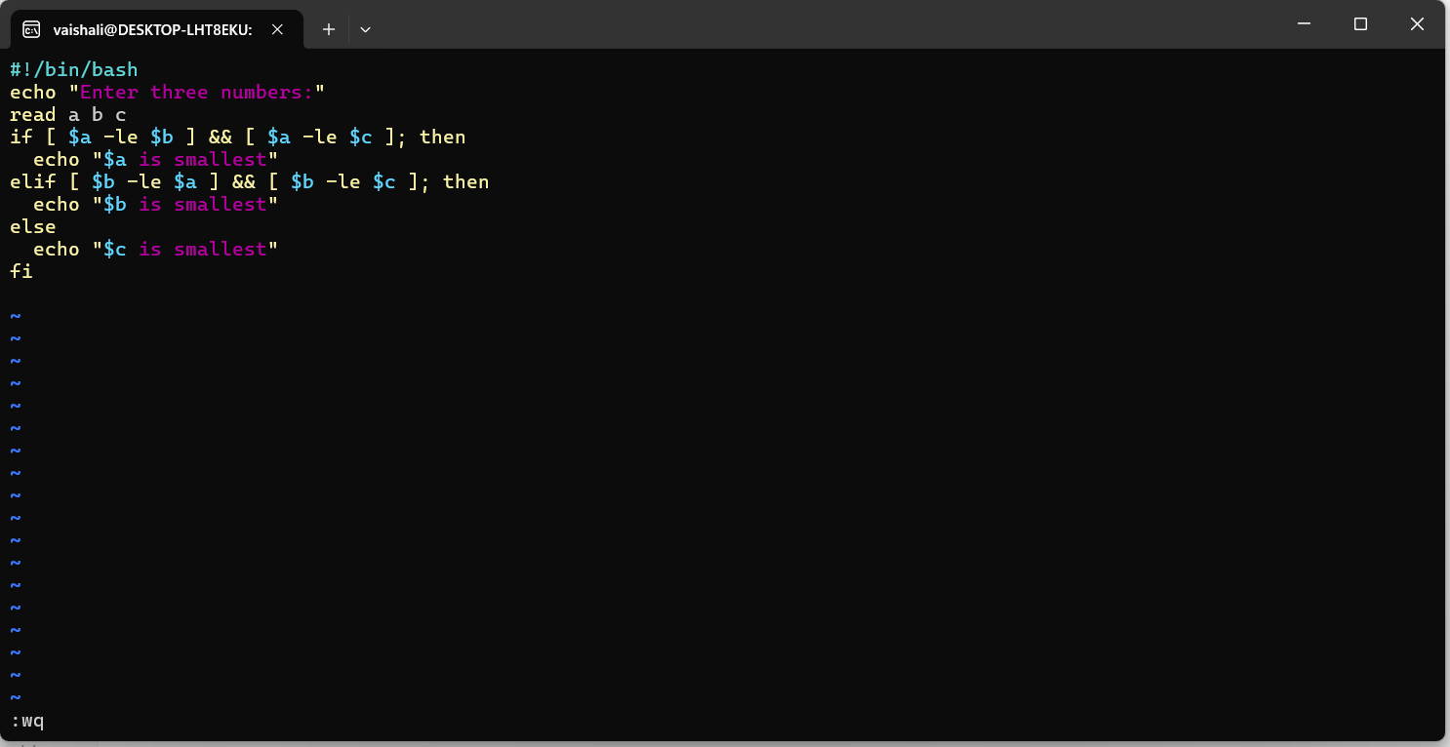
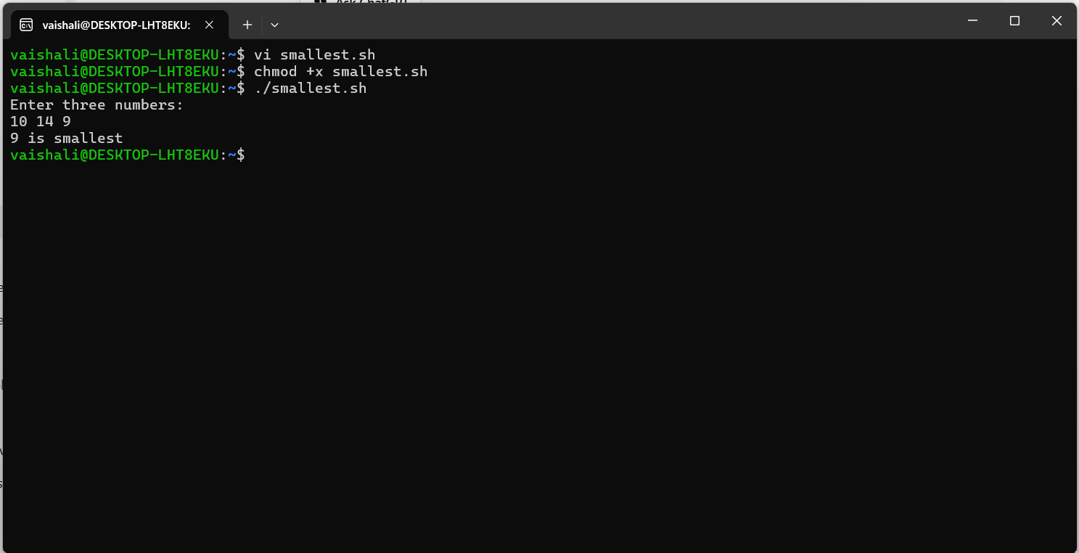

11. Write a shell program to count number of words, characters, white spaces and special symbols in a given text
STEP 1 : Create a file named- vi countall.sh
STEP 2: Press I, Write the code and then,Press Esc , then :wq, and hit Enter to save and exit.(if force quit then :q!).
STEP 3: To execute the file type chmod +x countall.sh
STEP 4: For output type ./ countall.sh

#!/bin/bash
echo "Enter a line of text:"
read text
chars=${#text}
words=$(echo $text | wc -w)
spaces=$(echo "$text" | awk -F" " '{print NF-1}')
special=$(echo "$text" | sed 's/[a-zA-Z0-9 ]//g' | wc -m)
special=$((special - 1)) # remove newline
echo "Characters: $chars"
echo "Words: $words"
echo "Spaces: $spaces"
echo "Special symbols: $special"

